South Island
German Shepherd League
Owners Manual

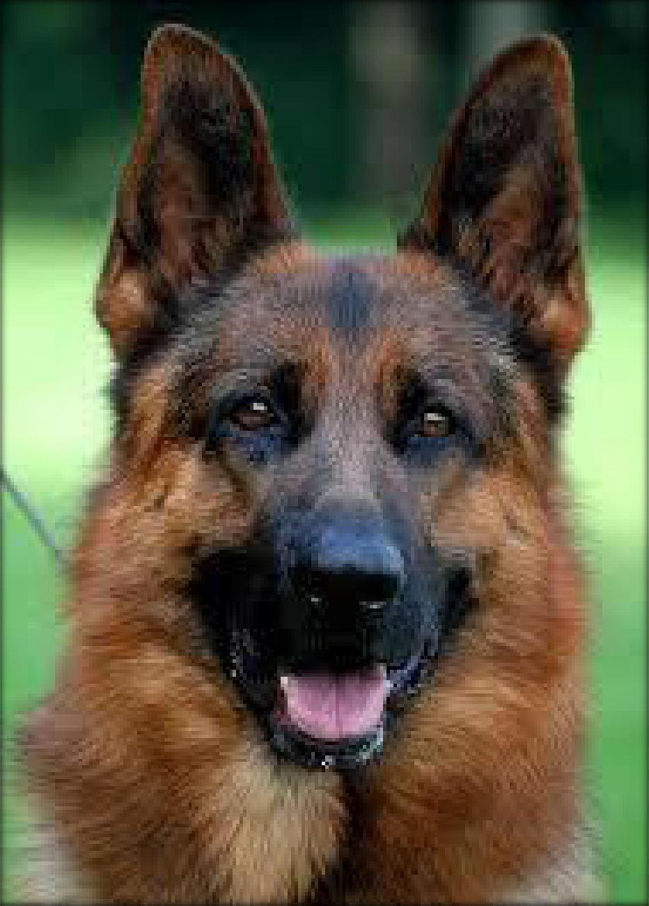

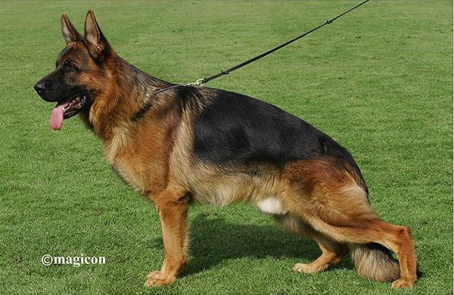

Introduction
The German Shepherd is known throughout the world for his loyalty, trustworthiness and multiple, utilization. As a working dog - to mention only a few of its functions – he is used by the armed services and the police, for protection, herding, tracking, rescue work, and as a guide dog for the blind. The possibilities for his employment have grown to such an extent that they are difficult to list.
His harmonious appearance, the calm and good-natured temperament, but also his readiness to protect when necessary, even in the face of danger are winning him more and more friends and admirers, are making him the most useful and respected companion.
Yet some of those who are buying a German Shepherd have no experience with the breed, how to keep and treat it, and it is mainly for those newcomers this booklet has been published as a valuable guidance.
Through incorrect keeping, rearing or feeding, many mistakes are being made which could be avoided, observing elementary rules would contribute decisively to the successful upbringing of a good utility dog.
The following summary should help to minimize mistakes. For the beginner it would provide you with important hints; for the experienced handler it may be refresh your memory of known facts.

References.
Thanks to Allan McKerran for providing an original manual.
Photos were obtained from Images of German Shepherd’s from the internet and the SIGSL archive of photos Some Information was obtained from several sites on the internet

Complied by Lynette Baker

South Island German Shepherd League (SIGSL)

The South Island German Shepherd League (SIGSL) club was established on the 28th July,1965. In 1996 the club relocated to the A & P show grounds, where we now have a new club building with up to date equipment.

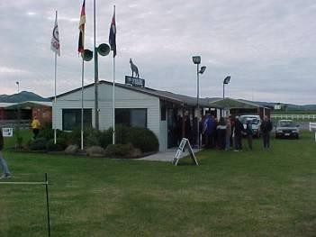

How to find us
Come in the Canterbury Agricultural Park main entrance off Cutlets Rd, turn right and keep following the boundary fence around (go past the stock yards - they will be on your right) and keep going until you get to the end of the sealed area. The clubrooms are by the loading dock.

Training Types and Times

Breed Showing – Wednesday’s 6.45pm and Sunday’s 10.00am

Obedience Training – Competitive and Domestic – Wednesdays 6.30pm Sundays 9.45am Agility – Competitive and just for fun – Wednesdays 6.45pm and Sunday’s 9.45am
Any enquiries please phone Blue Gardiner on 03 344 0390 or Sandra Van Kempen 021 2107 984

Breed Shows Showing dogs, is a great sport where the thrill of competition is combined with the joy of seeing beautiful dogs.
At a dog show, the main consideration is the dog's conformation or overall appearance and structure.

Specialty Vs. All-Breed -There are two types of conformation dog shows: specialty and all-breed. Specialty shows are limited to dogs of a specific breed or grouping of breeds; for example, the German Shepherd Specialty is for German Shepherds only.
All-breed shows, on the other hand, are open to over 130 breeds recognised by the NZKC. SIGSL holds or is host to seven breed shows throughout the year – 2 in April, 3 in June and 2 in November.

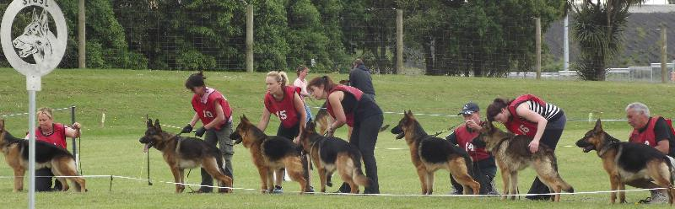

Obedience – Competitive Obedience is exactly what you would imagine – well trained and obedient dogs having their abilities tested. Obedience can be likened to dressage, or maybe gymnastics. The overall objective is to execute each exercise within a class with precision and accuracy, dog and handler working as a complete team. Thus both handlers and dogs can be penalised for errors and faults.
SIGSL holds one specialty obedience competition show per year – many other all types of breed shows are held around the Canterbury area. It is wonderful to have a beautiful German Shepherd dog competing in these competitions.

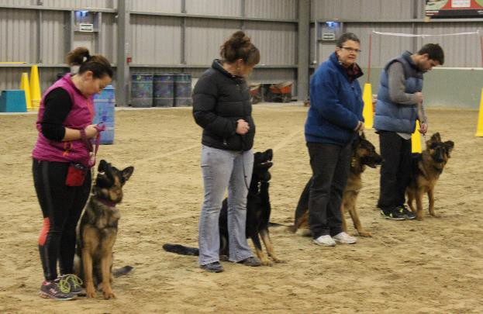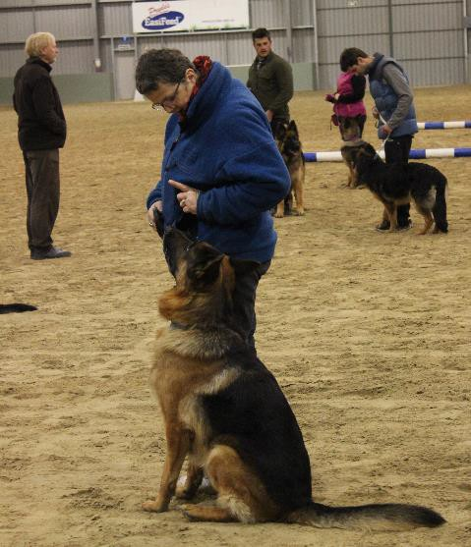
Agility – The club also offers agility training once your dog is over 18 months. We have up to date and up to standard agility equipment. Our main day of agility training is on Sunday morning’s 10.00am. The purpose of agility is to test the ability of a dog to accomplish a series of obstacles whilst under the control of the handler. Although speed is essential to achieve getting into the finals of a competition, steadiness is also important as the dog is off lead from start to finish and works only on commands from the handler.

The course has a series of obstacles that the dog must either jump over or go through – preferably without fault.

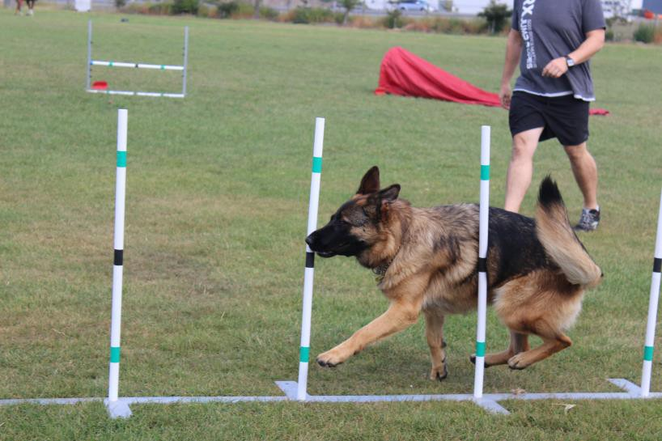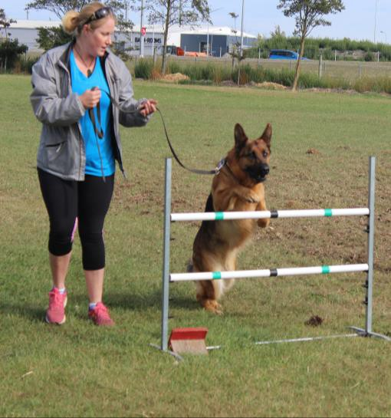

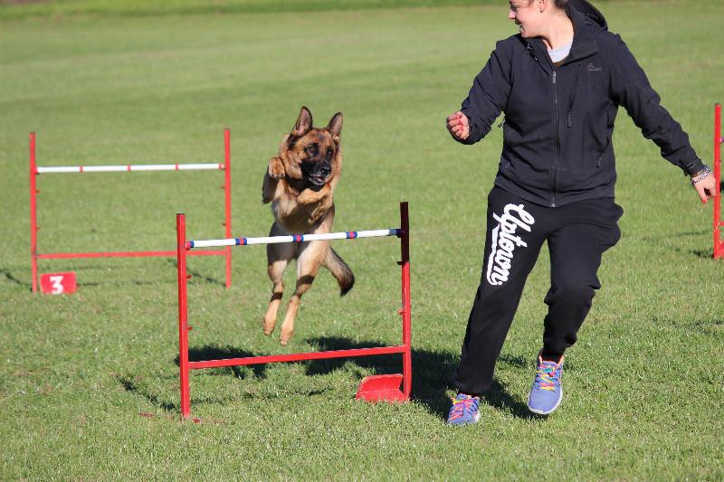

Puppy Training South Island German Shepherd league offers structured puppy training course in Domestic obedience.
For a small charge you will receive a folder with the complete course for your ongoing reference - also in this folder you will find a wealth of information tips and ideas.
The course runs over seven weeks and starts with a training session for you - the handler/owner and finishes with a graduation and certificate.
We have found the most important part of training your new pup is actually training the owners.
We aim to keep our classes casual and informal
Our puppy trainers have many years’ experience with German Shepherds.
Each training session runs for 40 minutes as this is long enough to hold your puppy’s attention but not too long so that he/she loses interest. You will also receive homework for the week We always can tell the following week if you have done your homework.

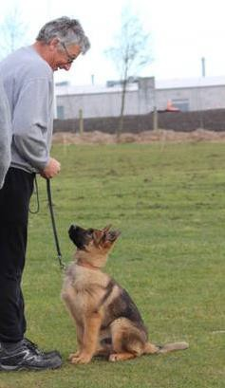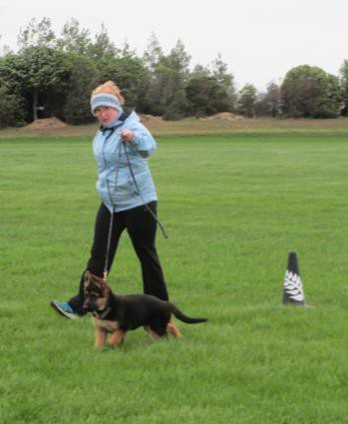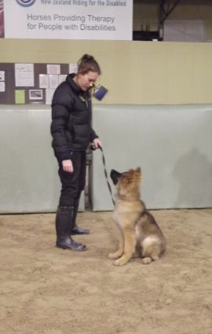

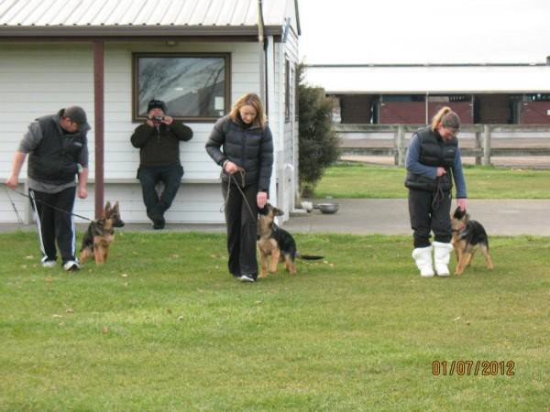

Origin of the Breed and its History

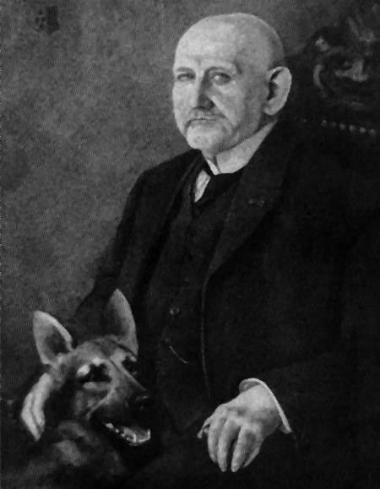It all started when a young German Cavalry officer stood on the crest of the hill, deep in thought and watching the sheepherder tending his flocks in the valley below. The sheep in this part of Germany were large and tough and appeared to be almost more than a match for the small dogs herding them. They kept the sheep from straying into the cornfield nearby, herding them together when carriages approached on the road and permitted them to scatter and graze when it was safe.
While the German Cavalry officer watched, fascinated, he envisioned a dog of medium size who could cope with the two different sized breeds of sheep found in Germany, he saw a dog who would be extremely intelligent, quick on his feet, protective if necessary, noble in appearance, trustworthy in character, physically sound so that he could work tirelessly all day long and born with innate desire to please. A dog who could reason and
be a companion to man, when the farsighted cavalry officer, Max Von Stephanitz, returned to his regiment, he promised himself that he would start a utilitarian breed of dog that would be known as a German Shepherd, and so it was, this day in the 1890’s that the idea of founding a new breed come into being.
Throughout the 1890’s Captain Max von Stephanitz experimented with breeding dogs and he used many of the ideas the English dog breeders were using in England. He was vitally interested in German Shepherd dogs because they were a true working dog of that era. Down through the centuries these dogs had developed exceptional sharp senses and instincts, plus the preposition to work.
In 1891 –Von Stephanitz founded the Verein für Deutsche Sch·ferhunde, SV (German Shepherd Dog Club), becoming the first president, and achieved the standardization of form and type in the
breed. A standard was developed based on mental stability and utility. The captain's motto was "Utility and intelligence". To him beauty was secondary, and a dog was worthless if it lacked the intelligence, temperament, and structural efficiency that would make it a good servant of man. A breed standard was developed as a blueprint dictating the exact function and relationship of every aspect of structure, gait, and inherent attitude. After only three years the society was disbanded, due to internal conflicts of its members. Some members wanted to breed dogs for their looks while others were more interested in breeding for the traits and workability of the dogs. This society didn’t achieve their aims but they did succeed in raising the interest of others to breed dogs to a specific standard. One of those people was Max Von Stephanitz. Max was a huge believer in breeding dogs for working.

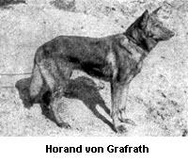In 1889 Captain Max von Stephanitz began the standardization of the breed. It all started at a dog show in Karlsruhe in western Germany. A medium-sized yellow-and-gray wolf-like dog caught his attention. The dog was of the primal canine type, supple and powerful, and possessed endurance, steadiness, and intelligence. He was a working sheepherder, born with this ability, requiring no training other than direction and finish to become proficient at the task. This dog, Hektor Linksrhein, was purchased by von Stephanitz, renamed Horand von Grafrath, and became the first registered German Shepherd Dog. Stephanitz inbred heavily on Horand Von and also Luchs, his brother, to
consolidate the bloodline. Horand's best son, Hektor von Schwaben, the second German Sieger, was mated with his half-sister as well as through daughters of his own sons, Beowulf, Heinz von Starkenberg, and Pilot III.

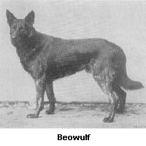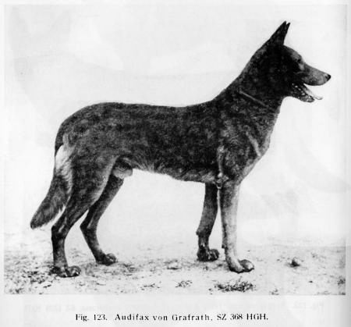Intense inbreeding also concentrated undesirable recessive originating from the mixing of the original strains. Von Stephanitz then inserted unrelated blood of herding origin through Audifax von Grafrath and Adalo von Grafrath.

Audifax von Grafrath

So you’ve already read how Max created the German Shepherd and things had been steadily progressing but Von Stephanitz realised with the modernisation and industrialisation of Germany it may result in a downturn for the need of shepherding working dogs and so he looked for other opportunities for the breed. He found another purpose and that was of service to the military and police and rescue, he worked with the authorities to introduce the German Shepherd for these roles. Around 1910 there were about 500 police stations in Germany who were equipped with trained police dogs. During the First and Second World Wars the dogs were used as ammunition, message, first aid supply carriers, mine detectors, sentinels and guard work to name but a few. American Soldiers were so taken with the bravery and loyalty of the dogs that they captured some and took them home with them after the war ended, which also helped raise the popularity of the dog in countries other than Germany. Popular shows such as Rin Tin Tin and Strongheart during the 1920’s also helped.
Back in Germany they were holding a German Shepherd dog show each year to judge the very best of the best male and female who would then be awarded the title of Seiger and Seigerin. Of course after being judged the best of the best many dog breeders would want to breed their bitches to this now, very influential sire - of the year, therefore there was of great importance as to what dog was selected as those bloodlines of that dog had a great impact on the breed.

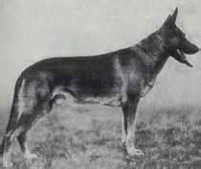In 1925 Stephanitz was becoming worried that the direction of his beloved creation was taking a wrong turn. He was concerned about the height and box type shape of the dog. At that year’s Seiger show he was a judge and he selected a dog by the name of Klodo von Boxberg as the Seiger for that year. Klodo was of a different look than all his Seiger predecessors, he had a longer body, was a bit shorter than his competition and had that
far reaching gait that we all know and love in our German Shepherds. This marked the
change in the appearance of the German Shepherd but not the traits, which remain the same –
Intelligent, good temperament, courageous, versatile,
devoted and loyal. Von Stephanitz discouraged
breeding for beauty and instead focused on ‘purpose’ in line with the well-known quote
“utility is the true criterion of beauty.”

Klodo Von Boxberg

German Shepherd Conformation and Standard

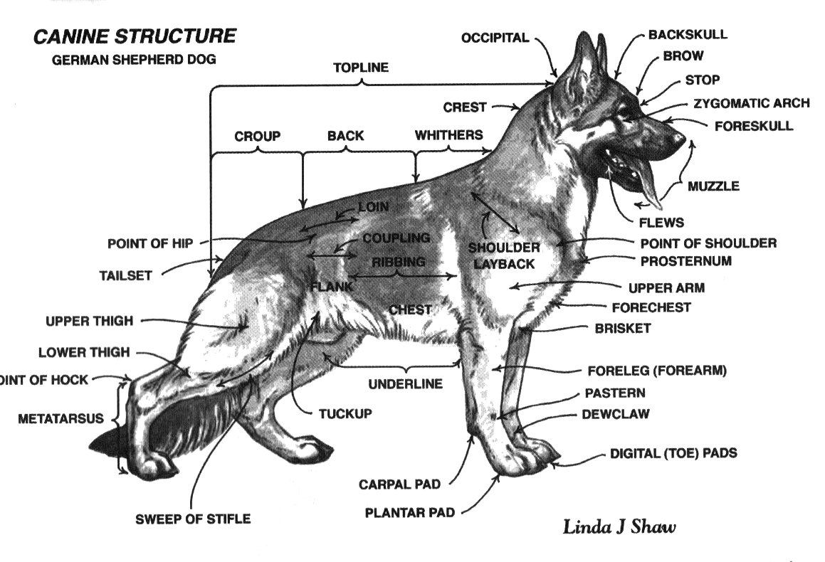

The breed standard of the German Shepherd Dog relates to the physical constitution as well as the traits and characteristics.
GENERAL APPEARANCE
The German Shepherd Dog is medium-size, slightly elongated, powerful and well-muscled, with dry bone and firm overall structure. The height at the withers amounts to 60 cm to 65 cm for male dogs and 55 cm to 60 cm for female dogs.
Character
The German Shepherd Dog must be well-balanced (with strong nerves) in terms of character, self-assured, absolutely natural and (except for a stimulated situation) good-natured as well as attentive and willing to please. He must possess instinctive behaviour, resilience and self-assurance in order to be suitable as a companion, guard, protection, service and herding dog.
Head
The head is wedge-shaped, and in proportion to the body size without being plump or too elongated, dry in the overall appearance and moderately broad between the ears. Upper and lower jaws are powerfully developed. The nose is straight and black, any dip or bulge is undesirable. The lips are taut, close well and are of dark colouring.
The teeth must be strong, healthy and complete (42 teeth according to the dental formula). The jawbones must be strongly developed so that the teeth can be deeply embedded in the dental ridge.
The eyes are of medium size, almond-shaped, slightly slanted and not protruding. The colour of the eyes should be as dark as possible. Light, piercing eyes are undesirable since they impair the dog’s impression.
Dentition
When a puppy is born the teeth are not visible though the outlines can be picked up. Large breeds cut their milk teeth faster (4 weeks) than smaller ones (6 weeks). Female pups tend to get their teeth before male puppies. Summer puppies are also more likely to get their milk teeth earlier than winter puppies. These temporary milk teeth are usually not placed close together and as the pup grows the opening increases. The lower milk teeth usually come through before the top, however when the upper permanent teeth usually come through before the lower.
The German Shepherd Dog has a scissor bite, i.e. the incisors must interlock like scissors; the incisors of the upper jaw overlap those of the lower jaw. Overshot (top incisors extend out beyond the lower) and undershot (lower incisors extend out beyond the upper). Large spaces between the teeth (gaps) and straight (level) dental ridge of the incisors are also faulty.

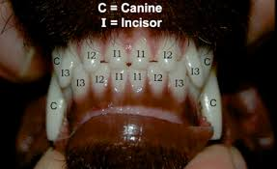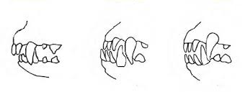
Scissor Bite Overshot Undershot Level

Ears
The German Shepherd Dog has erect ears of medium size, upright, pointed and face forward. Tipped ears and drooping ears are faulty. Ears carried rearward when moving or in relaxed position are not faulty.
Neck
The neck should be strong, well muscled and without loose neck skin.
Body
The top line runs interrupted from the base of the neck via high long withers, via the straight back towards the slightly long sloping croup and should merge into the base of the tail. The back is moderately long, firm, strong and well-muscled. The loin is broad, short, strongly developed and also well muscled.
The chest should be moderately broad, the lower chest as long and pronounced as possible.
The ribs should feature a moderate curvature; the chest not barrel-shaped or flat.
The tail extends at least to the hock and is carried hanging downward in a gentle curve, except in a state of excitement and in motion it is raised and carried higher.
Limbs
The forearms are straight when seen from all sides, and parallel to each other, dry and firmly muscled. The shoulder blade and upper arm are of equal length. The elbows may not be turned out or pushed in either while standing or moving. The paws are rounded, well closed and slightly arched; the soles are hard, but not brittle. The nails are hard, strong and a dark colour. The position of hind legs are slightly backwards. The legs are strong and well muscled. The hocks are strongly developed and firm; the hind pastern stands vertically under the hock.
Coats

Coat Description
Your GSD has an outer coat that is straight, coarse and dense with flat hair that lies close to his body. The undercoat is thick and softer than the outer coat. The neck area has a longer and thicker coat compared to the rest of the body. Some German shepherds have slightly wavy hair with a wiry texture for the outer coat. Bred to do herding and police work, his coat can handle the cold nights. Plan on brushing your shepherd often. The German shepherd sheds constantly, so he requires weekly and even daily brushing, especially during the twice-a-year seasonal shedding. Brushing will help avoid mats and distribute his natural oils.

Coat Lengths
The German shepherd is available in four coats -- short with an undercoat, medium with an undercoat, long with an undercoat and long without an undercoat. The short coat is as described, short. The medium or plush coat is longer and fuller than the short coat.

(Long Stock) or Langstockhaar
You can get two sorts of Long Coats, one has an undercoat and one doesn’t. The above name is what is used for a German Shepherd with an undercoat.
All of the following is the same as in the standard for a Stock Coat as in the characteristics, temperament, head & skull, eyes, ears, mouth, neck, forequarter, body, hindquarters, feet, gate/movement. The final part is the coat & tail, which of course is different.

Long Stock Coat (Long Coat):
The topcoat should be long, soft and not close fitting, with feathering on the ears and legs, bushy breeches and bushy tail forming flags below. It should be short on the head including the inside of the ears, the front side of the legs, on the feet and toes, it is longer and heavily coated on the neck, almost forming a mane. The hair lengthens on the back of the legs to the pasterns or hock joints; and on the back of the thighs it forms distinct breeching.
A long coat without an undercoat you will see more of a parting of the hair along the dogs back and the hair around the ears and legs will be slightly different.
You will find that you have less hair around the house with a Long Stock Coat compared to Stock Coat.
Grooming of a Long Stock Coat is just as important as it is for a Stock Coat and should be done just as regular as you would for a Stock Coat. The only thing that would be more important to do especially through the summer is to check more between the toes for barley or spear grass and for matting.
Colours
Colours are black with reddish-brown, brown and gold to light grey markings; single-coloured black, grey with darker shading, black saddle and mask. Unobtrusive, small white marks on chest as well as very light colour on insides are permissible. The tip of the nose must be black in all colours. Dogs with lack of mask, light to piercing eye colour, light to whitish markings on the chest and the insides of the legs, pale nails and red tip of tail are considered to be lacking in pigmentation. The undercoat shows a light cream tone. White is not allowed.
Size and Weight
Male dogs: Height at the withers: 60 cm to 65 cm Weight: 30 kg to 40 kg
Female dogs: Height at the withers: 55 cm to 60 cm Weight: 22 kg to 32 kg
Testicles
Male dogs should have two obviously normally developed testicles completely in the scrotum.

Movement
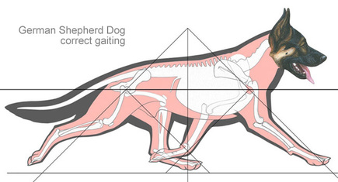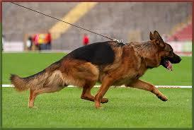

Stages of development for your Puppy.

Around weeks 7 - 12
This is an ideal age of socializing your German Shepherd puppy to humans, other animals and new surroundings and objects. It also a great time to learn such important skills as: leash training, housebreaking, crate training, accepting gentle handling and grooming and accept human control.
The socialization period is absolutely critical in GSD development and acceptance of other animal species. If a GSD puppy is not exposed to horses, sheep, goats, other dogs, cats or small children before it reaches 12 weeks, it is likely it will never accept them.
You may also observe that your German Shepherd pups ears are beginning to come up in some form or fashion. Don't be surprised by the wild and interesting shapes that they may take on as they mature. As the puppy goes through the teething process the ears will go up and down and will do all sorts of weird things - one up one down; one flopping; both in the center.
Around 3 Months
The socialization period of GSD development ends and the juvenile period begins. This period is thought to occur from the end of the primary socialization period through sexual maturity. All puppy teeth should be in by now and the German Shepherd puppy’s temperature is now at an adult level.
Motor skills are increasing for the GSD puppy. During this time the puppy is still refining both learning and social skills as well. While puppies in this phase can learn quite well, they are easily distracted and very hard to keep on task. This is an excellent time to start puppy kindergarten. This is also a good time to start being very aware of your GSD puppy’s ear carriage.
Around 4 Months
German Shepherd puppies will begin to lose their puppy teeth and will soon replace them with their adult teeth, generally starting with the incisors. Young German Shepherds will continue to learn about their environment and all the individuals in it. This is often the time when older puppies are learning about their social relationships within the environment they live. Social maturity takes more time to achieve than sexual maturity.
In the beginning of social maturity dogs will begin to display more mature, adult social behaviors.
This time is thought to vary between breeds and from dog to dog and to occur anywhere from 12 - 36 months of age, especially in the larger breeds such as German Shepherds.
Generally speaking, I do not consider my German Shepherds to be adults until the males are between 2 1/2 - 3 years old and the females are over 2 years old. Again, this varies from German Shepherd to German Shepherd. If your German Shepherd puppies ears are not standing up by this time on their own it is a good time to consider taping them.
Around 6 Months (or later)
At this age the pediatric period ends in GSD development. Overall, most of the puppies internal body systems are nearly "adult" even though the skeleton is still growing and will for some time to come. In many respects your German Shepherd puppy is now a "small adult". The heart rate has decreased again to about 70 BPM and by the end of this month the GSD puppy should have a full set of adult teeth.
Also an important milestone: German Shepherd females reach sexual maturity and have their first estrus (heat) period. If the GSD's ears are not up by this time you need to take action quickly to get them up before it is too late.
Around 7 - 12 Months
German Shepherd males reach sexual maturity and begin to hike their leg when urinating. It is important to be especially firm and consistent about setting limits and enforcing commands during this time since your older GSD puppy may challenge dominance of other dogs or humans during this stage. If the German Shepherd puppies’ ears are not standing on their own by this point, there is a good chance that they will never stand on their own.
Around 14 - 16 Months of Age
The German Shepherds attention span is now much longer. Bonding to humans is now very firmly established and your German Shepherds vocal and body communications are now that of a more mature individual dog - and more easily understood, and well on their way to many years of happy companionship with you.

Your New Puppy

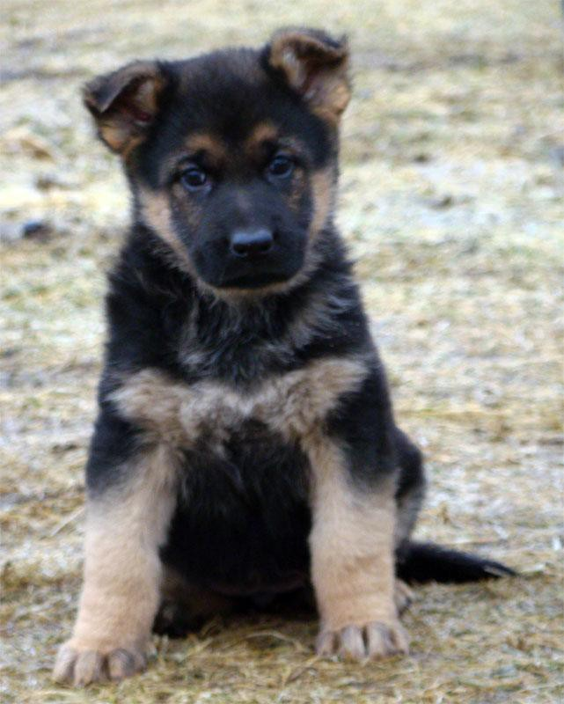
Bringing home a new dog is an exciting time. For some, it's the culmination of months of anticipation, and for all it is hopefully the start of a long, happy life together. This is a guideline.

How old should the puppy be?
Ideally, puppies should not be separated from their mother before 7-8 weeks of age. A good age to get your puppy is at 8 weeks of age as by this time they should be well weaned, solely on solids and hopefully starting to get the idea of toilet training, but you need to be prepared.
Puppy-proof Your Home A puppy will chew whatever they can get at in your absence so it’s important to keep your pup in an environment it can’t destroy. Dangers of special concern are electrical wires, poisons or tiny toys. You must put the puppy where it can’t do any damage.

Remember besides the destruction, the puppy may well injure itself. Keep puppies and small children apart or under close supervision. Small children don’t understand the need to keep fingers out of puppy’s eyes or not to pull painfully on their tails or legs. Children’s behaviour (eye contact and fast movements) can also be misinterpreted by a puppy as challenging or aggressive. Don't forget to make puppy play areas comfortable by placing flat mats, folded quilts, and old blankets down for your puppy to lie on. Puppy safe chew toys are great in the play and sleep areas to keep him/her stimulated and busy.

Supplies
    - Bowls: You will need two bowls for your puppy, one for food and one for water. Stainless steel is best as it's heavier than plastic and won't harbour bacteria. Ceramic works well also but can be easily broken or chipped if knocked over.
    - Gate: A gate is a helpful tool to block off a portion of the house, stairways or to close off a supervised playroom. Leaving your puppy in a large gated room may make your puppy feel lonely and displaced. Dogs typically feel safest in small manageable spaces because they are den animals.
    - Playpen: A playpen can be used to contain your puppy when you are out of sight, toilet training, accustoming to other pets and temporarily containing your puppy outside. They can be folded up and put away when not in use.
    - Crate: Crates are great because they give your puppy its own place to play, rest, and feel safe. A crate will keep your puppy safe in your home and your home safe from your puppy while you are away. They are available in plastic or wire. If you plan to travel with your puppy a plastic crate can be used in the home (in a well- ventilated environment) as well as while traveling. Wire crates have better airflow and can be made more den-like by covering it with a blanket at night.
    - Bedding: Store bought dog beds are great but it might be a good idea to wait until your puppy is house trained before spending money on one. You can use an old blanket or some old towels until your puppy is house trained. If your puppy likes to chew you may want to skip the bedding altogether to avoid the ingesting of fibres.
- Toys: With an overwhelming variety of choices out there, it's best to start with only one or two toys at first and see which one your puppy likes best, then stock up on that one. Typically toys that bounce and roll are big winners, especially those that are oddly shaped, as they tend to bounce randomly. Rotating the toys can help prevent boredom.

- Collars: Collars made of cotton, nylon or leather with a buckle to carry your puppy's ID tags, do not slide or choke. A lightweight nylon collar is ideal for a young pup. Make sure you are watching him/her for the first day or two of wearing the collar to be sure that your puppy has adjusted to wearing it. Be sure to check the tightness of the collar regularly as your puppy will grow quickly and the size will need to be adjusted. A good fitting collar should be snug enough so that it cannot slip off over your pup’s head, but you should still be able to fit a couple of fingers underneath it to ensure it is not too tight.
- Harnesses: Harnesses are great for walking and for riding in the car. Never take your puppy in the car without securing him/her with a car harness or in a crate. Beware of leaving your puppy in the car unsupervised – especially if strapped in a harness.
- Leashes: There are many different types of leashes. A nylon leash is lightweight and ideal for your new puppy’s training. Make sure your puppy is used to walking on the lead before venturing outside. You can practice walking around the house and garden first to get him/her used to it.

Your New Puppy When Arriving Home

The first 24 hours should be reserved as time for your puppy to adjust to its new home. Have designated areas set up for playing, sleeping, and feeding. They will make your puppy feel more comfortable. Play areas are best if they are in a carpet-free area and should be in an enclosed room or gated area. Toys can be kept in the play area. Sleeping areas need to be in a quiet space or crate where the puppy can go to get away from any chaos, or to sleep. A few toys in this area will also comfort your puppy. Ideally the feeding area should be near the play area or if your puppy is easily distracted then you can use the sleeping area or crate. Your puppy may jump right into your family with very little transition or it may sleep a lot for days. It may be up all night whining and crying or it may sleep all night right from the start. However, your puppy reacts, just remember that it is still very young and trying to adjust to its new home.

Toilet training by eight weeks of age most puppies are starting to get the idea of toilet training. However, they are still babies and will have accidents. Take your pup outside after they wake or just after having a meal, as these are times they will normally go to the toilet. Give them lots of praise when they go to the toilet in the right place. NEVER scold a puppy when they toilet in the wrong place. If you are not there when it happens, the pup will have forgotten all about it and your punishment will not be understood. If you catch the puppy in the act, then firmly say NO, and then take him/her outside.

Crate Training is the term used for the type of toilet training which involves using a puppy crate (cage, den, kennel) that you can close your puppy into at night or when you are away. This type of training can be very effective. It is natural for all dogs to have a ‘den’ and because dogs are very clean animals it is a natural instinct for them to keep their bed area clean and not toilet in the crate. Therefore, as long as you toilet them outside immediately before and after their time in the crate – you have a greater chance of getting your timing right and the opportunity to reward him/her when she does, therefore reinforcing the training.

Cleaning. Your dog should have its own towels and bedding. Ensure it is dry before using it again.

Tattooing. Some breeders still tattoo puppies about 6-8 weeks of age with their kennel prefix and an individual number in the puppy’s right ear. This is a quick identification of the dog if a micro- chipping scanner is not available.

Micro-chipping Since 1 July 2006, all dogs registered in New Zealand for the first time (except farm dogs used for stock control) must be micro-chipped. The unfortunate reality is that pets can get lost. When this happens it’s devastating. Micro-chipping is a safe, effective and inexpensive method to ensure a beloved pet can be reunited with their family. The microchip is approximately the size of a grain of rice and is inserted under the skin. It has a unique identification number that allows the pet to be tracked back to you with the aid of a scanner and database holding your contact details. All shelters and veterinary clinics have these microchip scanners and are able to identify an owned pet by contacting the registration service. It is then possible to contact you to let you know where your loved pet has been found. Vets can microchip your pet during a general health check exam, during a specific appointment or when they come in for any kind of surgery. At times the breeder may have already micro-chipped your puppy. The insertion procedure is quick and simple. For your pet it will feel much the same as having a vaccination injection.

Pet Insurance We often take our pet’s health for granted, but their health can be unpredictable. Pet insurance is available through vets and NZKC. It is not always possible to protect your pet from all unforeseen circumstances. Pet insurance removes the worry of cost becoming a factor if your pet is injured or develops a serious illness.

Vaccinations Several diseases can be fatal especially for little puppies. Fortunately, vaccinations are available to prevent many of these diseases. Puppies need to be vaccinated against: Distemper, Viral Hepatitis, Parvovirus, Para influenza and Leptospirosis. In many cases Bordetella or Kennel cough vaccine can also be given. Your vet will discuss the vaccination protocol and during the consultation the vet will also examine your puppy and check its general health. Vaccination protects your puppy against serious infectious diseases, which may threaten its life.
How Do Vaccines Work? Vaccines contain viruses that have been altered so that they don’t cause disease. When given a vaccine, your dog’s immune system produces a protective immune response, so that if later exposed to that disease, your dog quickly mounts a response to destroy the disease-causing virus.
When do I vaccinate my puppy? Newborn puppies receive immunity from the colostrum contained in the mother’s milk during the first few days of life. As this passive immunity gradually declines, the pup needs to be vaccinated to build up the pup’s own immune system and produce antibodies to various diseases. The vaccination schedule starts at 6-8 weeks of age with the first vaccination often given by the breeder even before you get the puppy. To ensure this immunity continues to develop booster vaccinations are repeated at 3-4 weekly intervals until 16 weeks of age. An un-well puppy should not be vaccinated. After this your puppy should have an annual check-up and vaccination to ensure the immunity is maintained.
- It is important not to expose your pup to infection by allowing it access to high-risk areas such as parks and other public places.
- The protection given by vaccinations is only complete if the whole course is given. Allow 10 days after the final injection for full immunity to build up before taking your puppy to risk areas.
- However, it is also important that your pup socialises at a young age with other dogs. If you know that a particular dog is up to date with its vaccinations, then you can let your puppy socialise with it in a safe environment under supervision (that is in a fenced section where contamination from unvaccinated dogs is unlikely, or puppy play school). Not dog parks

External Parasites
These include fleas, lice, ticks, and mites. They cause severe itching, inflammation, and with ticks sometimes death. There are collars, powders and drop treatments to control these parasites, but if you live in a tick area check your dog daily.
Fleas. These tiny pests are much more than an annoyance: they make life miserable and are the cause of flea allergic dermatitis in many dogs.
- A female flea can lay 2,000 eggs in her lifetime.
- Fleas can jump 150 times their own length; this is equivalent to a human jumping 1,000 feet.
In a young puppy, a heavy flea burden can suck a large amount of blood and cause a potentially serious anemia. Vets stock many flea treatments, some you can use safely from 2 days of age, and many will have a prolonged period of activity of 1 month or more. Revolution*, Comfortis* and Frontline* are often recommendations as effective and safe. Ask your vet for more information.

Worming Worms can present a serious problem to puppy health and can interfere with the puppy’s growth if left unchecked. Puppies most commonly become infested with roundworms. Other possible worm types include hookworms, whipworms and tapeworms.
Roundworms- Most puppies are born with roundworms and or are infected immediately after birth through their mother’s milk. Puppies can pass round worms in their feces, or cough or vomit them up. Worms often cause a pot-bellied, prominent ribs and backbone appearance, poor growth, lack luster in their coats and have flaky dandruff. Their appetite may also be poor and they may have diarrhea. Round worms are 4-6 cm long thin and pointed at each end.
Hookworms - Puppies are also born with these worms and acquire them through their mother’s milk. These are thread like worms are about 3cm long and attach themselves to the lining of the small intestine and suck blood. Puppies with hookworms often are anemic. These worms also migrate through the lungs causing coughing.
Whipworms - Mothers do not pass on these worms. Puppies get whipworms from contaminated soil with egg filled feces from other infected dogs. Whipworms live in a dog’s caecum (a pouch between the small and large intestines) and cause severe diarrhea sometimes with blood in it.
Tapeworms - These are rarely seen in puppies and are not transmitted from dog to dog. Dogs can get tapeworms from eating rabbits, rats and other rodents that are infected.
Heartworms - This parasite is not in New Zealand, but Australia. It lives in the right side of heart and in the blood vessels, which take blood to the lungs. Dogs with parent infections will show signs of heart failure on the right side. Dogs often develop a cough, have an intolerance to exercise, and as the disease increases in severity the abdomen will enlarge, the liver swells and the dog develops jaundice just prior to death. Dogs get heartworm through the larvae, which are carried by mosquitos. The mosquito then feeds on the dog and then larvae are released into the dog’s bloodstream, which migrate to the dog’s heart and an adult heartworm develops 4-6 months. This disease can be diagnosed by a blood test and successfully treated. To avoid heartworm, owners need to give regular monthly doses.
Vets can recommend the correct wormer for your pup and will usually give the worm tablet to your puppy during the vaccination consult. Puppies need worming every 2 weeks until 12 weeks of age, then every month until 6 months of age, then three monthly for the rest of the dog’s life. Worming tablets are not all created equal. Make sure you use a wormer that treats all worms.
  - Children can pick up worms and other parasite problems from their pets. Encourage children to wash their hands after playing with any animals.
  - Remove your dog’s feces from the park so your dog does not contribute to the worm contamination in the environment and increase public health risk.

Introducing your puppy to other pets. Introduce your new puppy to other members of the pet population s-l-o-w-l-y. It may be a good idea to keep your pup in a separate room or part of the house for the first few days. This allows other members to get used to his/her smell and noises. It will also give your puppy chance to relax and adjust to his/her surroundings before having to face the next hurdle. If there is more than one other animal in your menagerie, introduce the newcomer to one pet at a time, so you don't overwhelm him/her. Let your new puppy and the other(s) sniff and inspect each other. They may growl and bark at first, but this may simply be a sign of insecurity.
Try reassuring ALL of your pets that everything's fine. Make sure you don't neglect them as you try to make the new pet welcome. Don't use physical force to put the older animals in their place; this may make them wary of the new arrival. Never leave your new puppy unsupervised.

Puppy School. Puppy classes provide a safe environment where pups can successfully learn to interact with other people and dogs. The classes also provide the dog owner with important information regarding living with a dog in your family. These sessions help you to form a close and strong bond with your puppy while allowing socialisation at this critical young age with other puppies. This should allow you to avoid common behavioral problems and pitfalls later in life. Sound habits are taught right from the beginning. Vets regularly run puppy classes and once your puppy is fully vaccinated the South Island German Shepherd Club also welcomes puppies.
Registration All dogs over the age of 3 months must be registered. The cost varies depending on whether the dog has been de-sexed and whether the owner holds a dog license. Please check with your local authority or council for details.

De-sexing As a responsible dog owner you should consider de-sexing your dog if you do not intend to use it for breeding. De-sexing ensures you do not have the burden of unwanted litters of puppies. There are also health reasons for having dogs de-sexed. Your de-sexed female will not have the strain of continual litters depleting her body of essential nutrients. De-sexing a female dog before her first heat means she is much less likely to develop mammary growths (breast cancer), and infections of the uterus. As an owner you will also not have the problem of keeping the male dogs away when she is on heat. When you neuter your male dog, the benefits include a reduced chance of prostate problems and the elimination of testicular tumors. There will also be a reduction in roaming and thus reduced dog fighting and a reduction in dominance based aggression towards people. It also takes care of those embarrassing sexual habits of dogs. The operation is performed under general anesthesia by experienced surgeons under sterile conditions in our surgical theatre. Vets often give pre- and post-operative painkillers and send home anti-inflammatory pain relief tablets for a few days. Surgery is usually performed from 5 months of age, before they reach puberty, to prevent your dog learning unwanted behavioral traits. Note that if you wish to show your dog in the conformation ring they cannot be de-sexed.

Grooming. It is important to make your puppy feel comfortable about grooming from an early age. Look into its eyes, ears, nose and mouth regularly. Their strong fast-growing nails should be trimmed regularly with a nail clipper or grinder to avoid overgrowth, splitting and cracking. There are a variety brushes and other grooming aids such as nail clippers. Grooming requirements differ from coat types, but long-haired dogs need grooming daily, short haired about once a week There are a variety of shampoos for dogs but don’t use detergents, disinfectants. More brushing can be expected during shedding season. An occasional bath will keep them clean and looking their best. Grooming can be a wonderful bonding experience for you and your pet.

Feeding By seven to eight weeks of age puppies should be on puppy food only. They should be fed three small meals a day to help with their rapid growth. Good premium puppy pet food is especially designed with puppy’s growth in mind and contains all the vitamins and minerals they require. It has the right balance of carbohydrates and protein and everything needed for their joints, bones and muscle development. In this day and age there are many good quality dog foods, produced by companies committed to research and health, so you will NOT need to supplement with extra vitamins (over supplementation can do great harm to growing bones and joints).
Depending on the size of your dog as an adult you are going to want to feed them a formula that will cater to their unique digestive needs through the various phases of their life. Many dog food companies have breed-specific formulas for small, medium, large and giant breeds. The German Shepherd Dog is a large breed and has a lifespan of 10 to 12 years. What you feed your dog is an individual choice, but working with your veterinarian and/or breeder will be the best way to determine frequency of meals as a puppy and the best adult diet to increase his longevity.
Helpful hints
- Beware of feeding human foods and leftovers, as there are many very harmful foods, which your dog cannot digest. (Chocolate, Avocado, Plums and Grapes are just a few.)
- Take care giving your dog bones of ANY kind, as the risks of chocking, blockages and intestinal upsets far outweigh the benefits – Do not EVER feed cooked bones to your dog.
- Do not change the puppies diet when you get home as leaving their mother is enough stress. Feed your puppy 3 times a day from 8 weeks to 6 months and then twice a day to 12 months. One feed a day is usually sufficient after 12 months. Do not overfeed your puppy, as this will cause associated bone disorders.
- Let your puppy eat in a quiet place and do not excite him during feeding, as this may cause obesity or contribute to a poor appetite. Just as important feed your puppy/dog when it is cool and they are rested from recent exercise, and try not to allow them to glop their food, encourage them to eat steadily and slowly, as some dogs are susceptible to “Bloat” (stomach torsion) which could be life threatening.
- Always provide and allow your dog to have fresh water.

Teething At around 4 to 5 months of age, puppies will start to get their permanent teeth. They lose the small front teeth first, then the premolars and molars at the back, finally the canine teeth come out. Sometimes the adult canines erupt before the baby teeth have come out and occasionally the retained baby canine teeth need to surgically removed. During this time of teething, some discomfort including bleeding gums is to be expected and your pup will want to chew more
As puppies begin to lose their “milk teeth” and get their 42 adult teeth they chew to help alleviate some of the discomfort they are experiencing. This is known as teething.
Below you’ll find several dog training ideas to help your puppy through these teething issues, and to keep your pup from being “bad” and to help it get through this stressful period.
- Give the Puppy plenty of exercise and attention to relieve boredom which often leads to chewing
- Do not give the puppy old shoes or socks to chew on - it cannot differentiate old ones from your
brand new ones
- Give your puppy one of its toys when it acts as though it may chew something it should not
- Use commercial sprays to alleviate chewing of household items - Listerine is also good
- Move items you do not want the puppy to get into out of its reach - cover all power cords, remove
pens/ pencils, plants (many are poisonous), books, etc.
- Crate the puppy if you cannot watch it
- Give your puppy toys of its own to chew on - it is also good to give these to your pup when he begins to teeth on you.
With a little bit of planning, patience and caring, you can help your German Shepherd puppy through this important teething stage of its life.
Did you know that dogs are perfectly capable of learning not to chew your stuff or bite on you – you just have to put in a little effort first.

Health - Like all breeds there may be some health issues, like hip and elbow dysplasia and eye disease. Some dogs may be faced with these health challenges in their lives, but the majority of German Shepherd Dogs are healthy dogs.

Exercise – It is important not to over exercise your puppy. The bones and joints are still very soft and can damage easily . Dogs don’t fully mature structurally until they are about 18 months old. General rule is 100 meters for each month of age up to 1 year on the leash. Unlimited exercise off the leash in the back yard is fine.

Guidelines

Up to 4 months – walk your puppy about 5 minutes (400 meters). If your puppy gets tired – stop. Don’t force it

to walk long distances, as it will try to please you by keeping up.

4-6 months – walk your puppy about 10-20 minutes (400-600 meters).

Allow plenty on rest

No jumping – lift your puppy in and out the car until it has reached 12 months

No running up and down stairs or steep hills – walk them slowly

No unsupervised playing with heavier dogs.

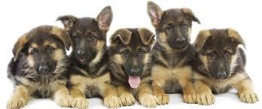

How to Establish Your Authority.

The way we live with our dogs is usually the cause of most problems. In order to show the dog that he is of the lowest rank in the family we need to establish rules. The following aren't in any order but they are all important. These rules should be laid down one at a time to avoid confusion or confrontation – it might take 3-4 days to establish the first rule you decide on, but persevere until it is well and truly understood before moving onto the next rule. As the dog understands each rule and he gradually loses his idea of being the top ranked individual in the family, the easier it gets. Strange as it may seem the key to understanding your dog is to understand how he views life as a member of your pack.

- Make sure you are the one who goes first though doorways or other narrow openings. The simplest way of achieving this is to close all doors in the house for a few days so the dog's freedom of movement becomes dependent upon the doors that you choose to allow him though. Don't tell him to stay, sit or wait at this stage, this is basically asking him if he minds if you go first. He should grant you the right of rank by allowing you to precede him. Have the dog on a lead at first, if he tries to barge in front, slam the door shut being careful not to trap his nose. You may have to repeat this several times, but he will get the message that when you open a door he wait.
- Make sure he does not occupy your beds or chairs. These are your special areas. Many owners say their dog is not allowed on furniture but not being allowed is different from not even trying. You should conversely be able to occupy the areas where your dog usually chooses to sleep. Besides his bed, there will be other places about the house he considers his own. Deny him access and make a point of occupying one of his special places when you choose to.
- Make sure you eat before he does. Either change his meal times to follow yours, or mix up his food in his presence, then make a point of sitting down and eating in front of him. The reasoning is the highest ranking dog in a pack eats first and gets the best pickings.
- Do not allow him to occupy key areas in the house. Busy doorways, main entrances, top steps are all areas that would be controlled by the Alpha (highest ranking) dog in a pack. Making these areas inaccessible is the easiest solution and although the physical barriers may be a nuisance for a few days, it will be worth it in the long run. Otherwise, simply make him get up and move from the spot each time you see him there.
- Make sure that when you go from A to B you do so by the shortest route. In other words, make the dog move out of your way even if he appears to be asleep. Making him wear a fight trailing line attached to his collar so you can pull him to one side makes the point very clear that lower ranks move aside for higher ranks.
- Make certain rooms in the house off-limits altogether especially your bedroom. Your dog should learn that although you have access to the whole of the house (den) he is only allowed in part of it.
- Do not allow him to demand attention. Dogs learn to do this in a variety of ways, nudging your arm for a cuddle or pretending they need to go outside to the garden when you have visitors or you're on the phone. All privileges should be earned even if it is as simple as sitting when he's told - then you can agree to his request.
- Having earned the privilege of being stroked you should only stroke him on the head, neck and shoulders. These are the dominant regions of dogs. If you observe two strange dogs meeting, after circling one another the most dominant dog will place his chin or paw on the neck or withers of the other dog. Crudely put, this means "I can break your neck if I choose to". Do not fall for the trick of a paw being placed on your arm in an attempt to get you to rub his chest or lying on his back for the same purpose.

- Remove his toys and possessions. Select one of these and keep it under your control. Insist he give it up when told. He should only be allowed to play with this toy when you want him to and even then, he should earn it first by obeying a command of some sort. Do not allow him to keep it afterwards - take it from him again until you want him to play again.
- Only allow him five minutes to eat his food. Dominant dogs have a habit of leaving some of their food for long periods of time as a visual display of their rank i.e. "this is my food and know no-one dares to eat it". Even if he starts to eat it after four and & half minutes. Don't allow him to paw you when requested to do something. This action is learned as a pup when the mother comes back to the den with a full stomach and regurgitates food to the pup. Make him do as he is told without touching or reaching for you.
- Make sure he greets you first thing in the morning and not the other way around. It is surprising how many owners of dominant dogs do every morning without realising. It is the lower ranks that approach the higher ranks to greet them in a dog pack.
- Increasing your control through regular obedience sessions, even if they last for only 5 minutes a day will help tremendously. These sessions should be done on a lead and collar so you are in a position of control and can insist the dog obeys.

Some of the above suggestions might sound mean and how can you deny those gorgeous wee puppy dog eyes – But – They aren’t puppies forever – Teach them when they are young to avoid all kinds of trouble when he/she grows up.

Basic training
SIGSL is a firm believer in Puppy Training and offers puppy training as soon as puppy has had its vaccinations. We also have training for all ages of dogs – once you join the club training is included with your yearly membership fee.
Make sure the training is enjoyable for the dog, and that he is willing and responds.
  - A puppy is ready for training as soon as you get it.
  - First make sure the puppy responds to his name.
  - Teach the meaning of “no”, but don’t keep saying ‘no’ to him or the word loses meaning.
  - Be consistent, use common sense and offer praise when your puppy does the right thing. If puppy is being a ‘rat bag’, distract him and give him something else to do.
  - Speak clearly and in a pleasant light voice whilst training and use words like ‘uh oh’ when they don’t quite get it right. Use a firmer growly type voice with ‘arrhhhhhhh’ followed by ‘leave’ for undesirable behavior. You will need to adjust volume and tone of your voice for the dog’s age.
  - Keep lessons short – about 10 minutes.

“Come”
It’s important that your puppy always comes when it is called. At the start add the word come to his name when you call. To help attract him clap your hands or offer a reward.

“Sit”
Place the dog on your left hand side and hold the lead in your right hand. With your left hand press firmly on his haunches while clearly saying “sit”. When the dog goes into a sit position praise him enthusiastically and repeat the process.

“Heel”
Place the dog on your left hand side and hold the lead in your right hand. Then say “heel” and begin walking in a straight line. Continuously encourage him to stay in line with you. If he moves away, jerk the lead sharply with your left hand and at the same time say heel. When you feel he understands, repeat without the lead.

“Stay”
Instruct your dog to sit. Stand facing him with the lead in your right hand. Tell him to “stay” as you move back the full length of the lead. If he stays, remain in that position for a few seconds and then walk back to him and praise him. Repeat his process without the lead, moving further away on each occasion and praise him.

Code of Good Manners

- Some people like dogs and others don’t. You need to be aware and respect their views
- Don’t allow your dog to jump on people. Give them a chance to become acquainted with friends and allow them to bark at strangers only until you take over then tell them to be quiet.
- A dog should never be out on the street on his own. The temptations can be too great.
- Keep your dog on a lead until you reach a safe exercise area. It’s safer to eliminate and avoid problems with other dogs, cats and vehicles, and is safer for young children and old people.
- Keep an eye on your dog when off lead in the exercise area as other dogs may be fighters as it’s usually the German Shepherd that gets the blame.
- Don’t allowing your dog to soil on the pavement or public areas, and if they do, pick it up.
- Teach and control your dog to walk next to you on a loose lead, it should not be a battle
- Teach and control your dog to leave and recall.
- Teach your dog to go down immediately where and when instructed for safety reasons.
- Your dog should always be under control.

Roaming
Dogs roam if they are not attended to, not fenced in, and are board. It is hard to retrain them once this habit is formed, and can be very annoying for your neighbours. Do not allow your dog to roam.

Barking - A barking problem is much easier to prevent than to cure!
Barking, along with whining, howling and growling, is a dog’s natural means of communication.
A dog may bark for a number of reasons: to induce play, discipline young, warn of danger, threaten intruders, or it may bark because it’s curious. None of these reasons tend to result in excessive or annoying barking – barking is short-lived and specific to an occasion.
Barking for companionship or for reward (food, freedom, etc.) is the most likely to develop into problem barking.
Causes of Problem Barking - In order to retrain a problem barker it is necessary to determine what factors may be triggering the behavior.
- Genetics- Some breeds are more prone to barking (e.g. terriers) although almost any breed can exhibit excessive barking.
- Physical Need - The dog is hot, cold, hungry or thirsty. This is the dog’s way of requesting that you accommodate one of its needs. A dog may become a problem barker due to insufficient exercise – the dog’s pent- up energy is released through barking.
- Emotional Need - The dog is bored, excited or anxious. This can be the dog’s way of requesting attention, or may be a compulsive behavior resulting from a frustrated need for social and/or mental stimulation.
- Environment- Improper confinement (restrictive tethering, being locked in a pen alone for long periods, lack of shelter) can all lead to a dog that barks excessively. Additionally, excessive barking may be triggered by environmental cues (other dogs barking, passing cars, sirens, storms, etc.).
Hints to stop barking
- Remove the motivation. Your dog gets some kind of reward when he barks.
- Think twice before ignoring
- Gently closing your dog’s mouth
- Have your dog bring you a present
- Bark on command
- Create distractions.
- Create training your puppy
- Bark collars
- Be the Pack Leader
- Desensitize your dog to the stimulus.
- Teach your dog the "quiet" command.
- Keep your dog tired

Your energy-packed Adult GSD requires physical activity to stay healthy.

Physical activity allows your GSD to have fun and maintain its fitness at the same time. German Shepherds are high-energy dogs that don’t like being bored. That’s why it is extremely important that GSD owners keep their dog busy in different activities. If a GSD gets bored or is left alone, it reacts. It starts to dig the ground, urinate everywhere, destroy your furniture, and much more. This is a normal reaction that GSD’s exhibit when they don’t get to play or exercise.

Ideas for exercising
- Take your GSD adult for a hike
- Take him/her for a swim at the river – being careful that the river is safe and algae free first.
- Find the Missing Object - Another fun way you can involve your dog in physical activity is by hiding a bone or your dog’s favorite toy in the ground or anywhere in the house. Show your dog its favorite toy or bone and then hide it. Your dog will be anxious to find it and will run around the home to look for it. This is a fun and highly energetic activity for your GS.
- Frisbee or Ball Playtime
- Time for some Morning Walk & Jogging
- Play Hide n Seek - GSDs are intelligent dogs and extremely curious, and that’s what makes them a perfect candidate for the famous Hide n Seek game. If you don’t have enough time to take your dog for a walk in the park, make use of your creative skills and play with your dog. Due to a GSD’s curious nature, it will be very excited to find you when you are hiding. Make sure that you say your dog’s name when you are hiding.

Think of creative and fun ways to involve in physical activity with your GSD. Giving time to your dog and taking it for exercises will strengthen your bond with it.

Hip Dysplasia
How do we prevent hip dysplasia?
Researchers agree that preventing hip dysplasia selective breeding is crucial, as it can significantly reduce the incidence of hip dysplasia. Breeding two animals with excellent hips does not guarantee that all of the offspring will be free of hip dysplasia, but there will be a much lower incidence than if we breed two animals with poor hips.
For someone looking to purchase a dog, the best way to lower the possibility of getting an animal that develops hip dysplasia is to examine the incidence of hip dysplasia in the litter's lineage. It is best to examine the parents and grandparents out to three or four generations.
There are many different theories on how to prevent the progression of hip dysplasia. Environmental factors can also contribute up to 70% chance of hip dysplasia occurring. Poor nutrition, over feeding, inadequate or improper exercise, jumping in and out of cars, on and off furniture, and decks, running up and down steps and steep hills, and increased body weight, heavy bone and loose ligaments with over exercising, and playing with other dogs unsupervised may all contribute to the severity of osteoarthritis and hip dysplasia.

Summary
- Hip dysplasia is a widespread condition that can affect large and giant breeds of dogs.
- There is a strong genetic link between parents and their offspring.
- There are other factors that contribute to the severity of the disease – nutrition, over feeding, over exercising especially heavy, loose ligamented puppies, jumping, and unsupervised playing with other dogs.
- Hip Osteoarthritis is degeneration of the joint due to a laxity caused by hip dysplasia.
- Surgical and medical treatments are targeted to prevent and treat the resulting osteoarthritis. The best way to prevent hip dysplasia is through selection of offspring whose parents and grandparents have been certified to have excellent hip conformation.

Further and more detailed information is available at the clubrooms – please feel free to ask.

