SOUTH ISLAND
GERMAN SHEPHERD LEAGUE INC

NEWS
Events and Stories
September 2017

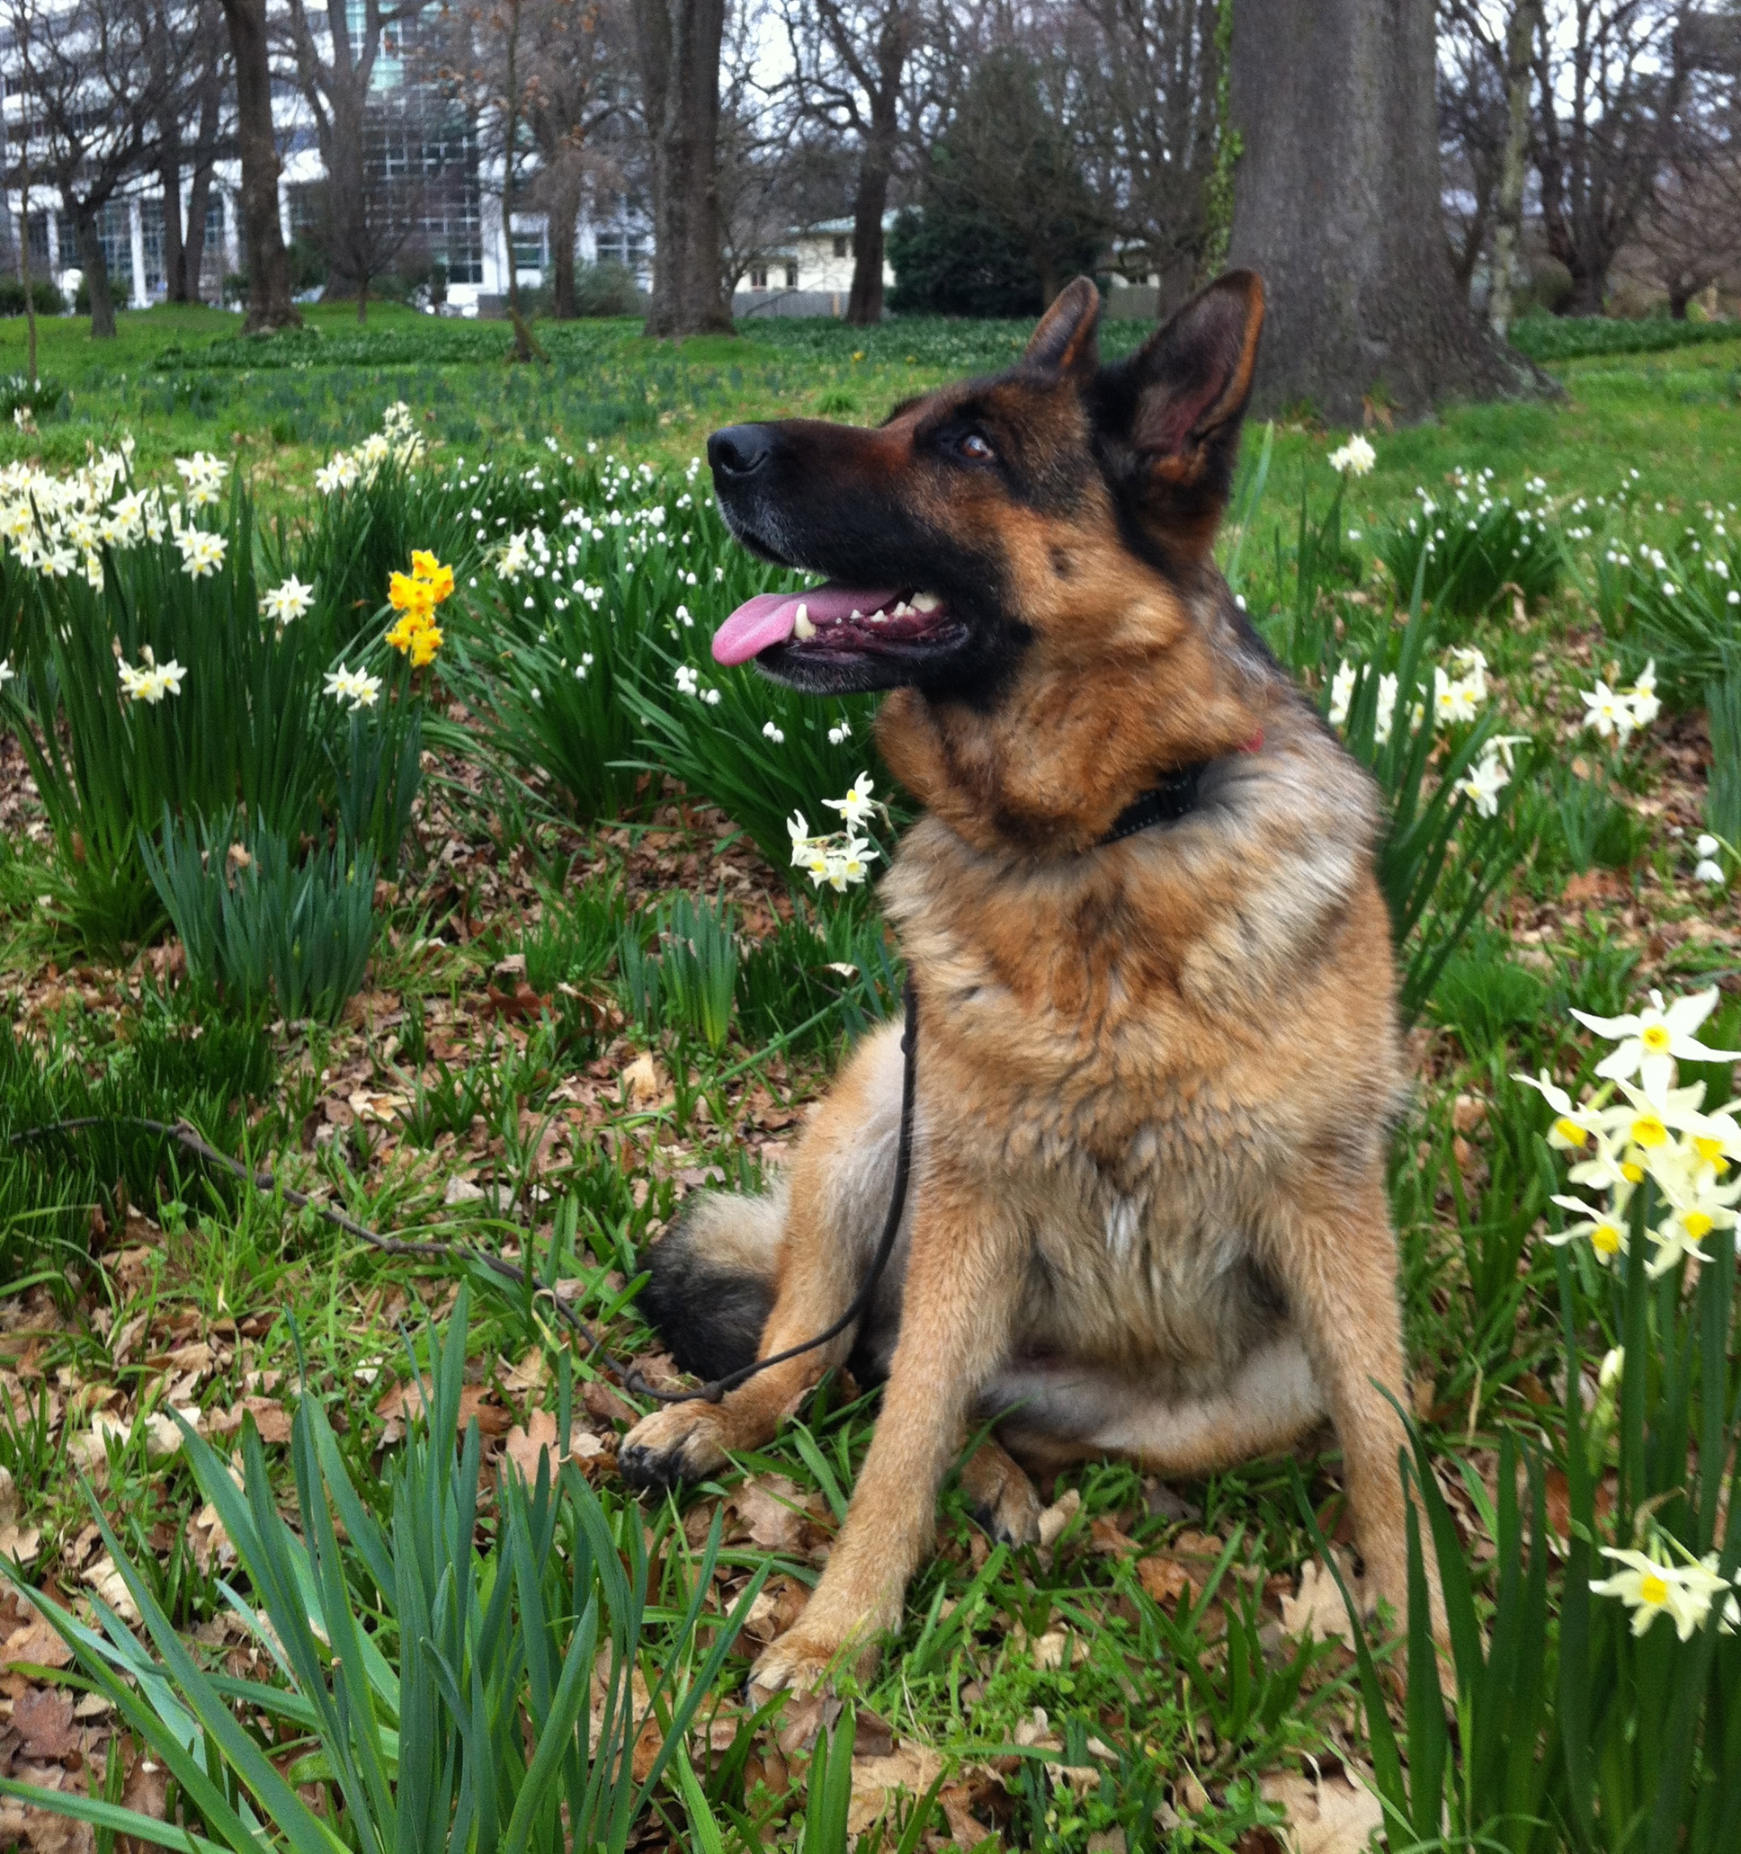

Its Spring, days are getting longer and warmer, and its SHOW TIME

EXECUTIVE

PATRON - BRUCE MAYHEW

Title | Name | Home Phone | Cell Phone | Email
President | Allan McKernan | 03 3441388 | 0274353210 | albara.gsd4us@yahoo.com
Vice President | Liz Wilkinson | 03 3238943 | 0274278644 | liz_wayne@xtra.co.nz
Vice President | Lynette Baker | 03 9653454 | 0210583566 | unfehlbar1@gmail.com
Secretary/ Treasurer | Lynette  Baker | 03 9653454 | 0210583566 | unfehlbar1@gmail.com
Show Secretary | Deb Bannan | 03 33275220 | 0274501065 | d.bannan@xtra.co.nz
Club Captian  (Not committee) | Sandra Van Kempen | 03  9818524 | 0212107984 | sandravk@paradise.net.nz
Committee | Evan Rahurahu | 03 3583845 | 0274700906 | rahu1@xtra.co.nz
Committee | Blue Gardiner | 03 3440390 | 0272358576
Committee | Andy Connor |  | 021448622 | andyleac@hotmail.com
Committee | Phil Baker | 03 9653454 | 0272555074 | philandlynette.baker@gmail.com
Committee | Nikki Flanagan |  | 0297719866 | nicola.flanagan@gmail.com

MEMBERSHIP: Lynette Baker
TROPHY STEWARD: Committee
PLANT MANAGER: Blue Gardiner, Phil Baker and Evan Rahurahu
SPONSORSHIP: Committee
CLUB SOLICITOR: Christine Eastgate, Corcron French, Kaiapoi
Corner Williams and Hilton St’s, PO Box 15, Kaiapoi 7644, T: (03) 327 8159,
F: (03) 327 5061, E: info@corcoranfrench.co.nz
LIFE MEMBERS: R Adcock, G & C Black, J & C Bucknell, B Gardiner, D Louch, B & J Mayhew, J & Nisbet, D Richards, D Saxton, P Ward, T & A Gibson, B, L Wilkinson, A & B Mckernan.
HONORARY MEMBERS: Christine Eastgate, Duguld Thomas, Darron Willett, Bill Townsend, Total Vets.
HONORARY VETS: Total Vets, 516 Gloucester st, Linwood
NOTICE EDITOR: Lynette Baker
CLUB GROUNDS: Canterbury Agricultural Park, Wigram Road
WEB SITE: www.sigsl.org.nz
CLUB ADDRESS: PO Box 2133, Christchurch.

SOUTH ISLAND GERMAN SHEPHERD LEAGUE

GENERAL INFORMATION

ANNUAL SUBSCRIPTIONS: (including newsletter)

Subscriptions due 31st March each year.
New Junior Membership $10.00 Renewal $10.00
New Single Membership: $40.00 Renewal: $40.00
New Double/Family Membership: $50.00 Renewal: $50.00

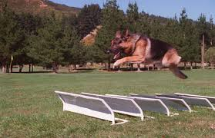
TRAINING:
Breed Presentation
Obedience,
Agility

TRAINING: Canterbury Agricultural Park, Wigram Road

WEDNEDAY EVENINGS FROM 6.30PM
Sundays 9.30am
At SIGSL clubrooms
Contact Blue Gardiner for further information Ph 03 344 0390

NEWSLETTER ADVERTISING RATES

STUD DOG DIRECTORY: $5.00 per year
BREEDERS DIRECTORY: $5.00 per year

CLUB MEMBERS:
Quarter Page: $25.00 per year
Half Page: $50.00 per year
Litter and Vale Notices Free to club members

COMMERCIAL:
Quarter Page: $50.00 per year
Half Page: $100.00 per year

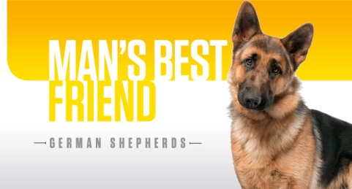

EDITORIAL



Hello Members.

Lynette Baker (Club Secretary/Treasurer) reporting on the SIGSL news, events and stories.

I will try to report the clubs news every 2 months but may also just email you if we have an urgent notice to get out to all our members.

Love to hear about your dogs and your stories, any adventures, qualifications and achievements so please feel welcome to share these, so I can share them with our wider SIGSL family.

CLUB NOTICE BOARD

Fundraisers

Allan has carpet squares available for sale - ideal for dogs crates e.t.c Large $5.00 small $3.00

Lynette is selling crates with a profit from each sale going to the club – see advert further on.

Sausage Sizzle at Mitre 10 Hornby is booked for the 7th January 2018

Championship Show and Open Show,
Open obedience Show and Open Agility

4th and 5th November 2017

SIGSL Club grounds, Canterbury A&P Park, Curtletts Road, Chch.

Judging order – Long Coats followed by Stock Coats & BIS both days
Obedience Staurday, Agility Sunday.
Reporting time 8.30am both days for breed,
Obedience and Agility to be advised.

Breed Classes – 1,3,5,6,8,11,1a,3a,5a,6a,8a,11a
Obedience classes – Elementary and Standard classes
Agility – Jumpers and Standard classes
Child and junior handlers Sunday Lunchtime

The SIGSL November 2017 show schedule is due September, Entries due October.

All entries will be accepted on line through the Dogs New Zealand website or can be sent to Deb Bannan our show secretary, 913 Main North Road, R D 1, Kaiapoi 7691, email d.bannan@xtra.co.nz.

Cheques to SIGSL or Internet banking BNZ 02-0842-0081118-00, name as reference

Entry fees for Gabriele are $25.00 for Baby puppy and $28.00 for all other classes.

Entry fees for Sharon are $23.00 for baby Puppy and $25.00 for all other classes.

Entry fees for obedience are $8.00 each test

Entry fees for Agility are $5.00 each test.

Catering available both days. Support our club and buy your food at the show.

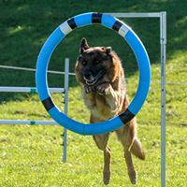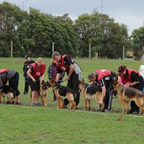

Sponsoned by


Breed Judges


Gabriele Pettinaroli – Italy (Saturday)

This year we are lucky to have Gabrielle from Italy for our Championship show.
Gabriele love of German Shepherd dogs originated from the love of his sheep, and as the German Shepherd was the dog to guard his sheep the progression happened. Gabriele got his first dog from a neighbour when he was five. His passion for the breed rapidly grew because of its companionship and usefulness. Gabriele then purchased a pedigree female, and later joined the SAS (Sociata Amatori Scaferhunde) in Italy.

When Gabriele was 10 years old he had his first litter and from that moment he dedicated himself to selecting and breeding. He Breeds under the kennel name of Isola Dei Baroni. Gabriele has had success in showing his dogs in Germany and Italy. Gabriele‘s bloodlines have been extensively used worldwide by breeders to improve front angulation, pigmentation and luxurious coats.

In 1978 I was appointed international specialist judge for German Shepherds,
selection judge in 1980 and S.V. breed judge in 1983.
Gabriele has judged all over the world, including Germany, all of Europe, Indonesia, Japan, China, Central and South America, Serbia, Australia and New Zealand.

Sharon Ballantyne Sunday
Sharon from Australia is no stranger to us and we welcome her back to New Zealand. She will be judging our open show on the Sunday.
Sharon and her mother bred under the name of Kantenna Kennels, which was established in 1964. Kantenna Kennels have over 50 years of continuous breed involvement and are committed to breeding and exhibiting dogs who display correct breed type with good-natured temperaments. To date they have bred over 60 GSD through the GSDCA National Hip Scheme, are the breeders of numerous Excellent Graded dogs, Australian Champions and Obedience Titled dogs, two Australian Siegerins Aust Ch *Kantenna Love Match (Silver Medal Winner) and Aust Ch *Kantenna Nutmeg (Gold Medal Winner).

Obedience - Carol Lavery (NZ) Saturday

Agility – Susan Tansey (NZ) Sunday
Height vs. Height

Thoughts from our president Allan McKernan

What has happened to our medium sized dogs?

Is this a measurement from the past?

I have always believed that the German Shepherd Dog was and is a medium sized working dog.

It was an ambition and a dying wish by our fonder of the breed, Captain von Stephanitz that breeders keep the German Shepherd Dog to a medium sized working dog. In his own breeding programme and his vigilant direction to other breeders, he always maintained the medium size dog for all those pioneer years.

In an effort to get our GSD’s back within the standard and correct size, I encourage breeders to start going back to selecting dogs of correct size, instead of flocking to the latest import regardless of size. All very well in using new bloodlines, but are we putting size as a lesser criteria?

I realize that this will take time, maybe two or three generations of breeding to achieve a satisfactory correct medium sized dog. This will not happen overnight, but with careful selective breeding, hopefully we will be heading in the right direction. I sincerely hope breeders in New Zealand will take a positive attitude towards achieving this.

Our surveyors can be instrumental as well by correct measuring and giving the appropriate Class 1 and Class 2 classification to a dog or bitch that is within the standard as indicated by the New Zealand Kennel Club. There must be no discrepancies with this.

If we are to remain affiliated with the W.U.S.V. then these surveys are to be done correctly and the possible end result will be a medium sized dog within the standard.
There will be more information made available from Herr Messler (Germany) and Louis Donald (Australasian SV representative) in the near future.

I wonder if breeders in New Zealand will think about reducing the size in our breed?
Will one day the oversized dog look out of place and Monty will be able to make a return to the show ring (Ha ha).

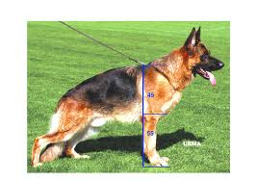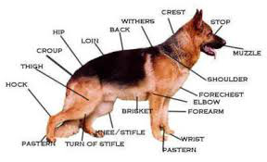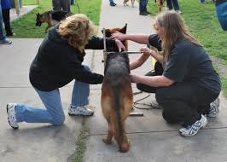

THE NEW ZEALAND KENNEL CLUB BREED STANDARD OF THE GERMAN SHEPHERD DOG

A breed standard is the guideline, which describes the ideal characteristics, temperament, and appearance of a breed and ensures that the breed is fit for function with soundness essential. Breeders and judges should at all times be mindful of features which could be detrimental in any way to the health, welfare or soundness of this breed.
FCI Standard No 166 dated 23 March 1991
Translated by German Shepherd Dog Council of Australia
Country of Origin: Germany
Group: Group 5 (Working Dogs)
General Appearance: The German Shepherd Dog is medium size, slightly elongated, strong and well muscled, the bones are dry and the overall construction firm.
The length of the body is greater than the height at the withers by about 10 to 17%.
Characteristics: Purpose and Usage: Versatile Utility, Herding, Guard and Service Dog.
Temperament: The German Shepherd Dog must be of well balanced temperament, steady of nerves, self assured, absolutely `at ease (except when provoked) and good natured as well as attentive and easy to train. He must possess instinctive drive, resilience and self-confidence in order to be suitable as a companion, watch dog, protection, service and herding dog.
Head And Skull: The head is wedge shaped, proportionate in size to the body, (length of head about 40% of height of withers) without being coarse or too elongated, in overall appearance dry and moderately broad between the ears. The forehead is only slightly domed when viewed from front and the side and without any or only slightly indicated central furrow.
The proportion of the skull to muzzle is 50% to 50%. The breadth of the skull corresponds approximately to its length. The skull (viewed from above) tapers evenly from the ears to the nose with a sloping, not sharply defined stop, into the wedge shaped foreface (muzzle). Upper and lower jaws are strongly developed. The top of the muzzle is straight, a dish faced or convex curve is not desired. The lips are tight, well fitted and of a dark colour. The nose must be black.
Eyes: The eyes are of medium size, almond shaped, slightly oblique and not protruding. The colour of the eyes should be as dark as possible. Light piercing eyes are not desirable as they detract from the expression of the dog.
Ears: The German Shepherd Dog has erect ears of medium size that are carried upright and almost parallel (not tilted inwards). They taper to a point and are set with the orifice to the front. Tipped ears and drop ears are faulty. Ears carried laid back, during gaiting or when at rest are not faulty.
Mouth: The dentition must be strong, healthy and complete (42 teeth conforming to the dentition formula) the German Shepherd Dog has a scissor bite that is, the incisors must fit scissor: like to each other so that the incisors of the upper jaw overlap those of the lower jaw in a scissor fashion. Level, over or undershot bites are faulty, as well as large gaps between the teeth. It is a fault when the incisors are placed in a straight line in the gums. The jawbones must be strongly developed so that the teeth are embedded deeply in the gum line.
Neck: The neck should be strong, and well muscled and free from throatiness (dewlap) the angle to the body (horizontal) is approximately 45 degrees.
Forequarters: The forelegs are straight viewed from all sides, and when viewed from front must be absolutely parallel.
The shoulder blade and upper arm are of equal length and firmly attached to the body with strong musculature. The angulation of the upper arm and shoulder blade ideally should be at 90 degrees but generally up to 110 degrees.
The elbows must be neither turned in nor turned out while in stance or in movement. The forearms when viewed from all sides are straight and absolutely parallel, dry and firmly muscled. The pastern is approximately one third of the length of the forearm and has an angle of approximately 20 degrees to 22 degrees to the forearm. Both infirm (more than 22 degrees) as well as steep pasterns (less than 20 degrees) restrict the working ability of the dog and in particular its endurance.
Body: The topline flows from the set on of the neck, over the high long withers and over the straight back to the slightly sloping croup without a noticeable break. The back is moderately long, firm, strong and well muscled. The loin is broad, short, strongly developed and well muscled. The croup should be long and slightly sloping (approximately 23 degrees to the horizontal) into the set on of the tail without disruption to the topline.
The chest should be moderately broad; the under chest is as long as possible and well developed. The depth of chest should be approximately 45% to 48% of the height at the withers.
The ribs should be moderately sprung, barrel-chested is equally faulty as slab sided.
Hindquarters: The position of the hind legs is slightly set back, when viewed from rear the hind legs are parallel to each other. Upper and lower thighs are of almost equal length and form an angle of approximately 120 degrees; the thighs are strong and well muscled.
The hock joints are well developed and firm, the rear pasterns stand perpendicular under the hock joint.
Feet: The front feet are rounded, well closed and arched. The pads are hard but not inflexible. The nails are strong and dark in colour.
The hind feet are closed slightly arched; the pads are hard and dark in colour. The nails are strong, arched and also dark in colour.
Tail: The tail extends to at least the hock joint, however, not beyond the middle of the rear pastern. It has slightly longer hair on the underside and is carried in a gentle hanging curve when relaxed. It can be carried higher when excited or during movement but not above the horizontal. Corrective surgery is forbidden.
Gait/movement: The German Shepherd Dog is a trotter. The limbs must be of such length and angulation that the hindquarter may be thrust well forward under the body and the forequarter reaches equally far forward without noticeable change to the backline.
Any tendency towards over-angulation of the hindquarter decreases the firmness and endurance and therefore the dog's utmost working ability. Correct structural proportions and angulations result in a ground covering, low to the ground movement that gives the impression of effortless forward propulsion. With the head pushed forward and a slightly raised tail, an even, balanced and smooth trot, results in a gently curving and unbroken topline, running from the tips of the ears and over the neck and back through to the end of the tail.
Coat: The German Shepherd Dog is bred in the coat varieties: stock coat and long stock coat, both with undercoat.
Stock Coat: The topcoat should be as dense as possible, straight, harsh and close lying. It should be short on the head, including the inside of the ears, the front of the legs, and on the feet and toes; it is a little longer and heavily coated on the neck. The hair lengthens on the back of the legs to the pasterns or hock joints; and on the back of the thighs it forms moderate breeching.
Long Stock Coat: The topcoat should be long, soft and not close fitting, with feathering on the ears and legs, bushy breeches and bushy tail forming flags below. It should be short on the head including the inside of the ears, the front side of the legs, on the feet and toes, it is longer and heavily coated on the neck, almost forming a mane. The hair lengthens on the back of the legs to the pasterns or hock joints; and on the back of the thighs it forms distinct breeching.
Colour: Black with reddish tan, black/tan, black/gold to light grey markings. All black, grey (commonly known as sables) with dark shadings; black saddle and mask. Unobtrusive small white markings on chest as well as very light colour on insides of legs permissible but not desirable. The nose must be black in all colour types. Lacking mask, light to piercing eyes, as well as light to whitish markings on chest and inner sides of the legs, light nails and red tip of tail are to be rated as lacking in pigment. The undercoat is of a light grey toning. The colour white is not permitted.
Sizes:
Dogs:
Height At Withers: 60-65 cm (23.6-25.6 inch)
Weight: 30-40 kg (66-88 lbs)
Bitches:
Height At Withers: 55-60 cm (21.7-23.6 inch)
Weight: 22-32 kg (48.5-70.5 lbs)
The length of body is greater than the height at withers by approximately 10:17%.
Faults: Any departure from the foregoing points should be considered a fault and the seriousness with which the fault should be regarded should be in exact proportion to its degree and its effect upon the health and welfare of the dog.

Orders taken for Beavers Pet products
Soft Dog Crate with curtains. $120.00 for XXXL Size suitable for German Shepherds.

Sells most dog products – Collars, Leads, Harnesses, crates, pens, car boot covers, bedding, toys and bowls.

Check out their website and say you are from SIGSL

www.beaverspetproducts.co.nz
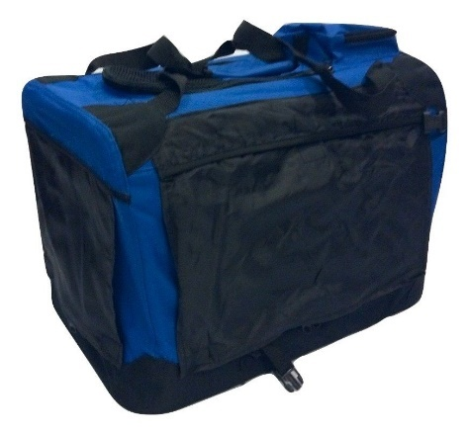
Colours available – Black, Blue, Maroon, Pink. Curtains are black.

600D water resistant fabric, rounded corners with 1000D fabric.
These canvas crates are made from 600D Nylon Oxford Fabric with PVC coating with a density of 150T and a weight of 200GSM. Not polyester which other cheaper crates that look the same. Nylon is a lot stronger than polyester, and all pet crates are not created equal!
Could be used for many different reasons - crate training, birthing/whelping, surgery recovery, camping kennel, bed for inside, car transportation and dog showing.
Features:
- Durable powder coated steel frame, easy to fold and unfold in seconds, and to store
- Injection moulded plastic frame lock
- Reversible base pad with warm fleece and cooling water resistant polyester
- Top storage pouch
- Curtains that can prevent from sun, wind and give your pet privacy when needed.
- 3-entry design, easy in and out, top, side and end.

Small Size: 500mm Long x 340mm Wide x 340mm High. $65.00
Medium Size: 600mm Long x 410mm Wide x 410mm High. $75.00
XLarge Size: 800mm Long x 570mm Wide x 570mm High. $100.00
XXXLarge Size: 1000mm Long x 690mm Wide x 690mm High – GSD size $120.00
Payment to SIGSL. Account number 02 0842 0081118 00

Order Quantity ___________________ Size _________________________ Colour ___________________

Your details
Name ________________________________________________
Address ______________________________________________________________________________________________
Email _________________________________________________________________________________________________
Phone contact _________________________________________

Orders to Lynette Baker
Email philandlynette.baker@gmail.com
Phone 03 9653454 or 0210583566
Delivery for out of town people could be 22nd and 23rd April SIGSL show.

BREEDERS DIRECTORY

CANTARA KENNELS

Liz Wilkinson and Wayne Perham
PO Box 20-180, Bishopdale, Christchurch
Phone: 03 323 8943
Mobile: 027 427 8644
E-Mail: liz_wayne@xtra.co.nz

GAVAROL KENNELS

Gavin & Carol Black 23 Innes Road, RD 7, Ashburton

Phone: 03 302 3934

E-Mail: gavrol@xtra.co.nz

HEATHCOTE KENNELS

Tony & Annette Gibson 448 Marsh’s Road, Christchurch

Phone/Fax: 03 3445421
Mobile: 027 4345739
E-Mail: gibsondec@xtra.co.nz

HUNDMEISTER KENNELS

Joan & Darren Evans 52 Topito Road, Tuahiwi, RD 1, Kaiapoi Phone: 03 313 7347

LORELEI KENNELS

Les Pauling lesp@xtra.co.nz
Porirua
_____________________________________________________________________________

OLDFIELDS GERMAN SHEPHERDS

John & Tracey Walsh 1 John Street, Hinds,
R D 3, Ashburton
Phone: 03 303 7399
E-mail: quena@xtra.co.nz

STATTLICH KENNELS

Bruce & Judy Mayhew 129 Turners Road, Oruhia,
Christchurch
E-Mail: mayhews@xtra.co.nz

Phone: 03 323 9717

WESTFIELD KENNELS

Jon Field Hoskyns Road, , West Melton, RD 5, Christchurch Phone: 03 347 8166
E-Mail: je.field@xtra.co.nz

WOMBARRA KENNELS

Barry & Jan Grives 2920 Tram Road, RD 5, Rangiora 7475
Phone: 021 241 8101 or 027 625 0176
or 03 312 5015
E-Mail: barryandjan@xtra.co.nz

STUD DOG LISTING

This is available for stud dog owners. Please enquire.




Lawyer Christine Eastgate
The Crossing, Corner Williams and Hilton Street,
PO Box 15, Kaiapoi 7644
Email: christine.k@corcoranfrench.co.nz
Tel: (03) 327 8159 | Fax: (03) 327 5061
www.corcoranfrench.co.nz

Legal Expertise
- Property, Business, Trusts, Wills,
- Enduring powers of attorney, Estates, Earthquake red zone.

